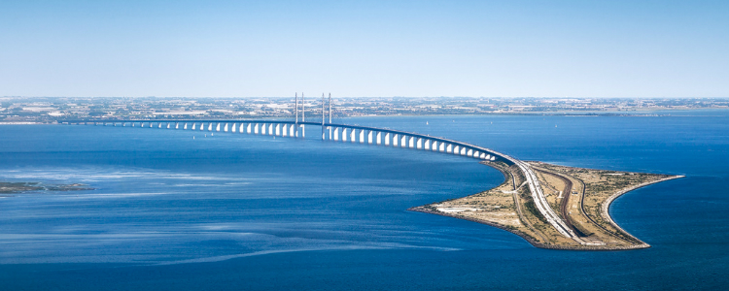
CONTEMPORARY ACHIEVEMENTS
ON CIVIL ENGINEERING
from study to practice

March 21, 2018 • University of Debrecen Faculty of Engineering • Room 222
open to all faculty and staff

conference agenda

8:45 – 9:00 |  | Registration
9:00 – 9:10 |  | Welcome Address  Dr. Imre Kovács, Head of Department  University of Debrecen, Department of Civil Engineering
9:10 – 10:00 |  | Real estate project management in holistic context  Zsolt Hintenberger, Dipl. Civil Engineer, MRICS, PMP  Realiscon
10:00 – 10:45 |  | Debrecen Smart City Strategy  László Mátyus, Economist, Smart City senior expert  Debrecen Urban and Economic Development Center, Debrecen Smart City
10:45 – 11:00 |  | break
11:00 – 11:45 |  | Concrete connections and slim floors  Ádám Takács, Dipl. Civil Engineer  Peikko Group
11:45 – 14:00 |  | lunch break
14:00 – 14:15 |  | Towards Integrated Water Resources Management  Aminu Siddique Mohammed  UD Department of Civil Engineering
14:15 – 14:30 |  | Civil engineering wonders in the world  Adam Abdulmalik - Sunusi Umar Tanko  UD Department of Civil Engineering
14:30 – 14:45 |  | Abdali Project  Yousef Alhaj Saleh - Mohannad Gharaibeh  UD Department of Civil Engineering
14:45 – 15:00 |  | The architects and construction of Taj Mahal  Hafiz Muhammad Ismail  UD Department of Civil Engineering
15:00 – 15:15 |  | Cracks in Concrete  Moenga Philip Maigo  UD Department of Civil Engineering
15:15 – 15:30 |  | Experience in pasta bridge Competition  Ibrahim Al-amin - Ahmed Hashim - Galyaki Brian Castrol  UD Department of Civil Engineering
15:30 – 15:45 |  | Sustainability development of arch bridge structures  Ndagijimana Kevin  UD Department of Civil Engineering

Civil Engineering Days • Spring Semester • 2018 • University of Debrecen • Faculty of Civil Engineering

