CYCLE PARKING FACILITY ON THE ENGINEERING CAMPUS

Dear Students,

bicycles can be parked in the locked inner courtyard (car park). There you can find Sheffield hoops in front of Building B and next to the walkway connecting Building A with Building B.
Access info: You can get to this inner courtyard from Dembinszky Street.
Map:
https://unideb.hu/hu/elerhetosegek/?searchPoi-home-category[2013765]-poi[813]
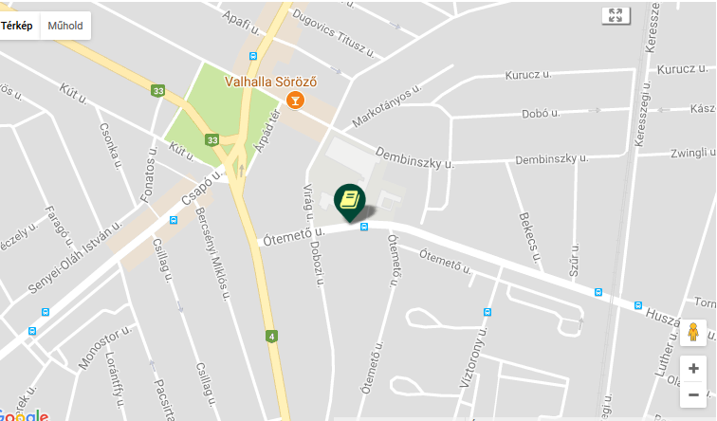
It is safer to store bicycles here rather than in front of Building A in the street or next to the park.

