Electromobile design, production, assembly and test at the
Faculty of Engineering, UD

There are several international race car competitions in which our student teams have been taken part successfully for years. The cars are driven compressed air and electric motors. In this two week course the construction of an electromibile will be introduced, designed, produced, manufactured and assembled by our student teams. The program contains the basics of automotive constructions; designing and modeling different parts of the car; workshop practice; 3D printing of parts; material tests and diagnostics.
The course ends with testing and driving the electromobile to make recommendations for further developments.

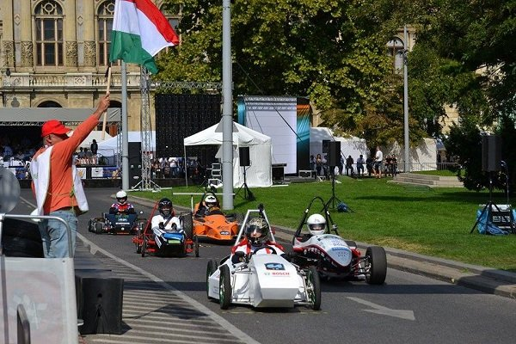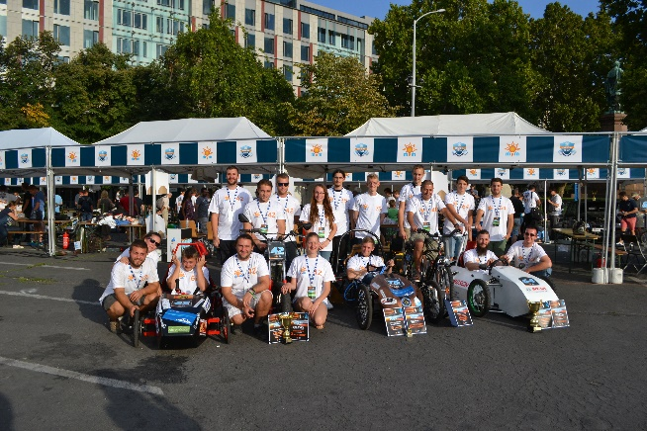

Week 1
 | Monday | Tuesday | Wednesday | Thursday | Friday
1 | Automotive constructions | Automotive constructions | Automotive constructions | Automotive constructions | Automotive constructions
2
3 | Workshop DEMK TEAM- Shell Eco-marathon | Disassembly of the vehicle and trouble shooting | CAD Modeling and Finite Element Simulation of  vehicle parts | CAD Modeling and Finite Element Simulation of  vehicle parts | Machining the designed vehicle parts
4
5 | Disassembly of the vehicle and trouble shooting | CAD Modeling and Finite Element Simulation of  vehicle parts | CAD Modeling and Finite Element Simulation of  vehicle parts | Machining the designed vehicle parts | Machining the designed vehicle parts
6

Week 2
 | Monday | Tuesday | Wednesday | Thursday | Friday
1 | Producing the designed vehicle part (welding) | Producing the designed vehicle part  (3D printing) | Material testing of vehicle parts | Assembly of vehicle and adjustments | Diagnostic tests of moving and rotating parts
2
3 | Producing the designed vehicle part (welding) | Producing the designed vehicle part  (3D printing) | Material testing of vehicle parts | Assembly of vehicle and adjustments | Testing and driving the electric car
4
5 | Producing the designed vehicle part (welding) | Producing the designed vehicle part  (3D printing) | Material testing of vehicle parts | Diagnostic tests of moving and rotating parts  Diagnostic | Testing and driving the electric car
6

