Short-term Summer Course on
Environmental Engineering, Environmental Technology
The aim of the course is to transfer modern and practice-oriented skills of Environmental Technologies. Participants learn up-to-date knowledge in natural elements, environmental problems and damages and learn how to utilize natural resources rationally, develop and operate environmental and cleaner technologies. Students get professional practical knowledge in the following areas of Environmental engineering: water management, waste management, air quality technologies, environmental analysis, noise and vibration protection, etc. This course will contain some professional visits to connecting plants, too.
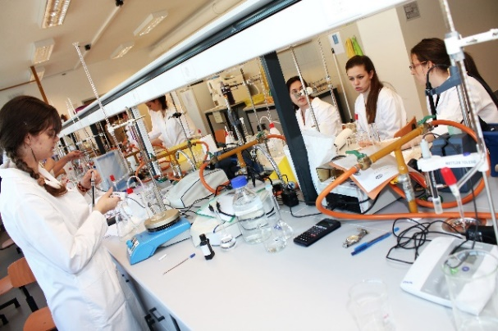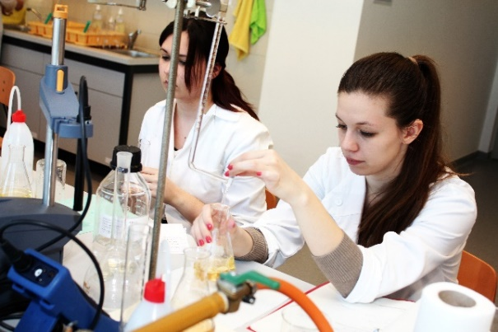

Week 1
 | Monday | Tuesday | Wednesday | Thursday | Friday
1 | Water management lecture | Air Quality Monitoring lecture | Soil protection lecture | Noise- and vibration protection Laboratory Practice | Waste Management lecture
2
3 | Water management practise | Environmental analysis lecture | Soil protection practise | Modelling with IMMI | Professional visit at WWTP of Debrecen
4

5 | Noise- and vibration protection lecture | Environmental analysis Laboratory Practice | Calculation with MATLAB | Air quality site visit | Professional visit at WWTP of Debrecen
6
Week 2
 | Monday | Tuesday | Wednesday | Thursday | Friday
1 | Water management lecture | Air Quality Monitoring lecture | Soil protection lecture | Noise- and vibration protection Laboratory Practice | Waste Management lecture
2
3 | Water management practise | Environmental analysis lecture | Soil protection practise | Modelling with IMMI | Professional visit at Landfill of Debrecen
4

5 | Noise- and vibration protection lecture | Environmental analysis Laboratory Practice | Calculation with MATLAB | Air quality site visit | Professional visit at Landfill of Debrecen
6

